**LOCALLY GROWN & PRODUCED**

**LOCALLY GROWN & PRODUCED**

**LOCALLY GROWN & PRODUCED**

**LOCALLY GROWN & PRODUCED**

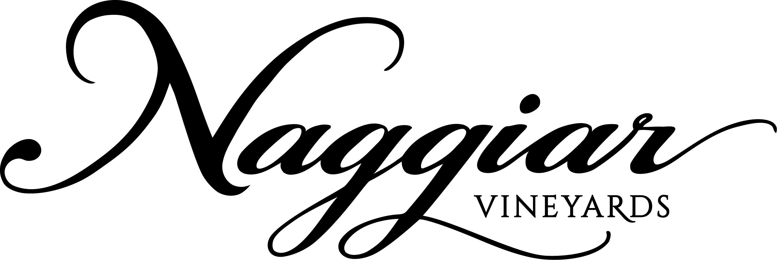***2016 Malbec***

Bursting with aromas of black plums, blackberry and hints of mocha and cedar, this wine has a rich mouth feel and a lingering soft finish.

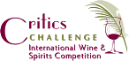

**Platinum, 94 pts**

**Best Malbec**

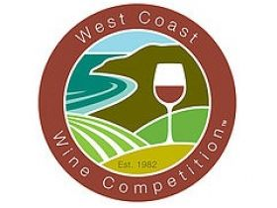

**Gold Medal**

***2016 Malbec***

Bursting with aromas of black plums, blackberry and hints of mocha and cedar, this wine has a rich mouth feel and a lingering soft finish.



**Platinum, 94 pts**

**Best Malbec**



**Gold Medal**

***2016 Malbec***

Bursting with aromas of black plums, blackberry and hints of mocha and cedar, this wine has a rich mouth feel and a lingering soft finish.



**Platinum, 94 pts**

**Best Malbec**



**Gold Medal**

***2016 Malbec***

Bursting with aromas of black plums, blackberry and hints of mocha and cedar, this wine has a rich mouth feel and a lingering soft finish.



**Platinum, 94 pts**

**Best Malbec**



**Gold Medal**