**LOCALLY GROWN & PRODUCED**

**LOCALLY GROWN & PRODUCED**

**LOCALLY GROWN & PRODUCED**

**LOCALLY GROWN & PRODUCED**

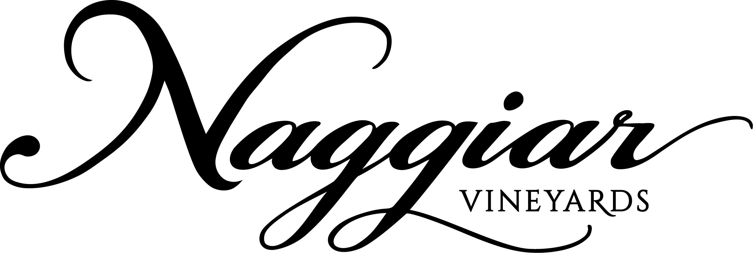***2016 Sangiovese***

Smooth and distinctive, this lovely vibrant ruby colored Sangiovese is made from grapes lovingly grown at our family estate vineyards. Aromas of black cherries, red plum, thyme, bay and cinnamon are followed by bright acidity with a lingering finish of cinnamon and toasty oak. This wine is an excellent companion for Italian dishes and can be enjoyed now or over the next few years.



**SILVER MEDAL**

***2016 Sangiovese***

Smooth and distinctive, this lovely vibrant ruby colored Sangiovese is made from grapes lovingly grown at our family estate vineyards. Aromas of black cherries, red plum, thyme, bay and cinnamon are followed by bright acidity with a lingering finish of cinnamon and toasty oak. This wine is an excellent companion for Italian dishes and can be enjoyed now or over the next few years.



**SILVER MEDAL**

***2016 Sangiovese***

Smooth and distinctive, this lovely vibrant ruby colored Sangiovese is made from grapes lovingly grown at our family estate vineyards. Aromas of black cherries, red plum, thyme, bay and cinnamon are followed by bright acidity with a lingering finish of cinnamon and toasty oak. This wine is an excellent companion for Italian dishes and can be enjoyed now or over the next few years.



**SILVER MEDAL**

***2016 Sangiovese***

Smooth and distinctive, this lovely vibrant ruby colored Sangiovese is made from grapes lovingly grown at our family estate vineyards. Aromas of black cherries, red plum, thyme, bay and cinnamon are followed by bright acidity with a lingering finish of cinnamon and toasty oak. This wine is an excellent companion for Italian dishes and can be enjoyed now or over the next few years.



**SILVER MEDAL**